5th feb

50 euro on Noble yellow card ---Lost 50 euros

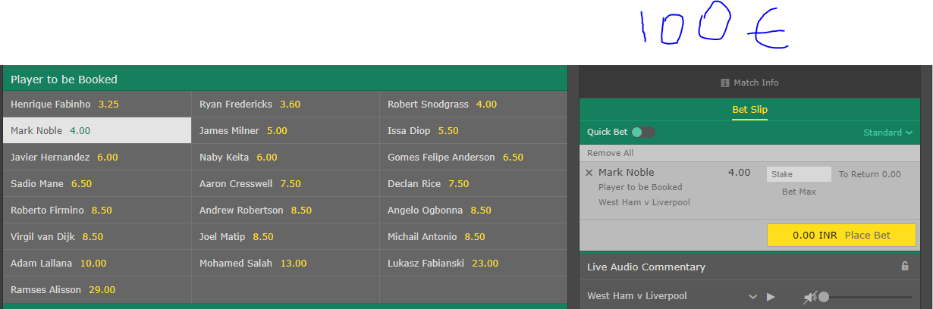

50 euro on Corners—61 euros won

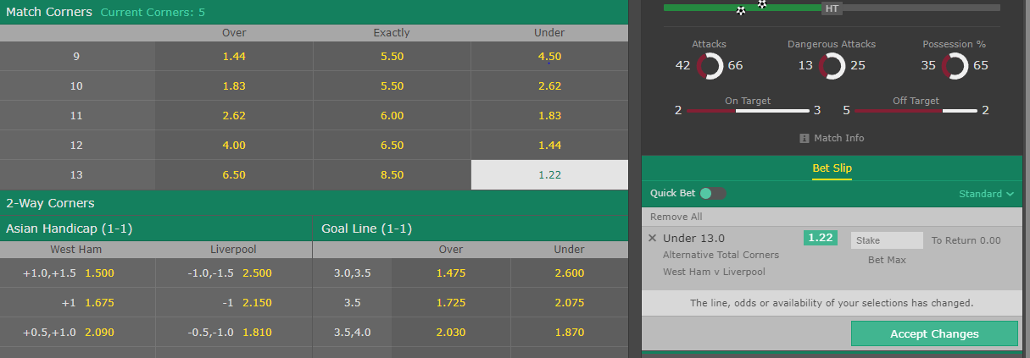

Salah on target-101.35 won

